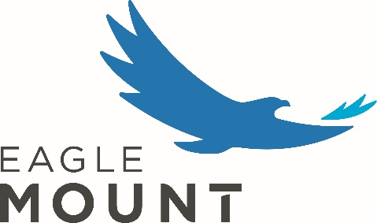
Adaptive Aquatics Assistant

Eagle Mount Bozeman is a non-profit organization that provides adaptive recreation for people with disabilities and camps for young people with cancer. The role of the Adaptive Aquatics Assistant is to support the delivery of the Adaptive Aquatics program. The Adaptive Aquatics Assistant is a regular, part-time position, supervised by the Adaptive Aquatics Director.

General Responsibilities:
- Adhere to all Eagle Mount policies, procedures, and guidelines; maintain confidentially of all participants.
- Represent Eagle Mount in a professional and courteous manner.
- Support and advocate for the organization and its affiliated programs and partners.
- Maintain healthy relationships with Eagle Mount community including participants, volunteers, and staff.
- Attend to administrative duties, attend required meetings, and staff training events.
- Exhibit patience, respect for others, appropriate stress management, and a desire to learn and grow.

Primary Duties
- Support program scheduling and communication activities.
- Support the coordination of daily classes and aquatic activities.
- Serve as a lifeguard when staffing the aquatic center.
- Lead adaptive aquatics activities and lessons when needed.
- Care for and maintain program facilities, equipment, and supplies.
- Maintain appropriate records and documentation for participants, volunteers, and donors.
- Assist with recruitment, training, motivation, and recognition of volunteers.

Required Qualifications
  - Strong communication, interpersonal, management and organizational skills
  - Ability to lift or move objects up to 50 pounds
  - Ability to work in warm, humid conditions, and to work in the pool for up to 4 hours
  - Ability to work well with individuals of all ages, with a variety of disabilities
  - Lifeguard, CPR, First Aid/AED certifications (can be provided by Eagle Mount upon hire)

