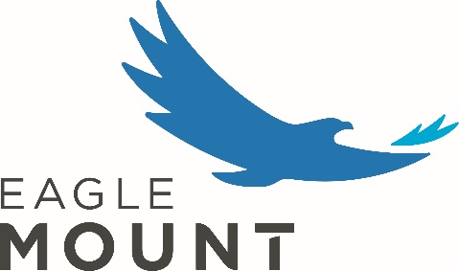
Marketing Intern
Position Description

Position Overview
The marketing intern will support Eagle Mount’s overarching marketing, branding, and engagement strategy. This is an amazing opportunity for an individual interested in learning more about the many facets of marketing and branding through the lens of a nonprofit. This internship offers hands-on experience and an opportunity to gain new skills and work with wonderful people.
This is an unpaid internship position with a flexible schedule, which may include weekends and evenings, based on needs. College credit eligibility must be determined by your academic advisor, but Eagle Mount is happy to work with you to structure this internship for credit. The intern will be expected to work off-site and in the office as needed. The intern will report to the Marketing and Engagement Manager and will work closely with other staff members and volunteers.
Responsibilities
All Eagle Mount employees and interns must:
- Adhere to all Eagle Mount policies, procedures, and guidelines; maintain confidentiality of all participants and volunteers
- Represent Eagle Mount in a professional and courteous manner
- Support and advocate for the organization and its affiliated programs and partners
- Maintain healthy relationships with Eagle Mount community (participants, volunteers, vendors, staff)
- Exhibit patience, respect for others, appropriate stress management, a desire to learn and grow
In this role, you will:
- Create and post on behalf of Eagle Mount through Instagram and Facebook
- Draft marketing/engagement emails to be sent to a variety of different audiences
- Assist in direct mail campaigns to prospective donors
- Assist with small graphic design projects
- Engage with potential volunteers and participants at tabling events
- Assist in data hygiene and upkeep
- Assist with miscellaneous Eagle Mount tasks as needed

Requirements
- Part-time: May – September 2024 (dates can be flexible)
- Must have reliable transportation

Qualifications
- Interested in the mission of Eagle Mount and the work of nonprofit organizations
- Organizational skills to manage multiple tasks
- Attention to detail
- Creative and positive, with great people skills
- A motivated self-starter able to work with minimal supervision and is highly reliable
- Strong verbal and written communication skills
- Ability to work both independently and as a part of a team

If you are interested in this position, please email our Marketing and Engagement Manager at mrabidue@eaglemount.org with a resume. Thank you for your consideration! By helping us carry our mission and vision, you will have an opportunity to make a real impact, while developing both personally and professionally.

